Important Links

- The Florida Channel – https://thefloridachannel.org

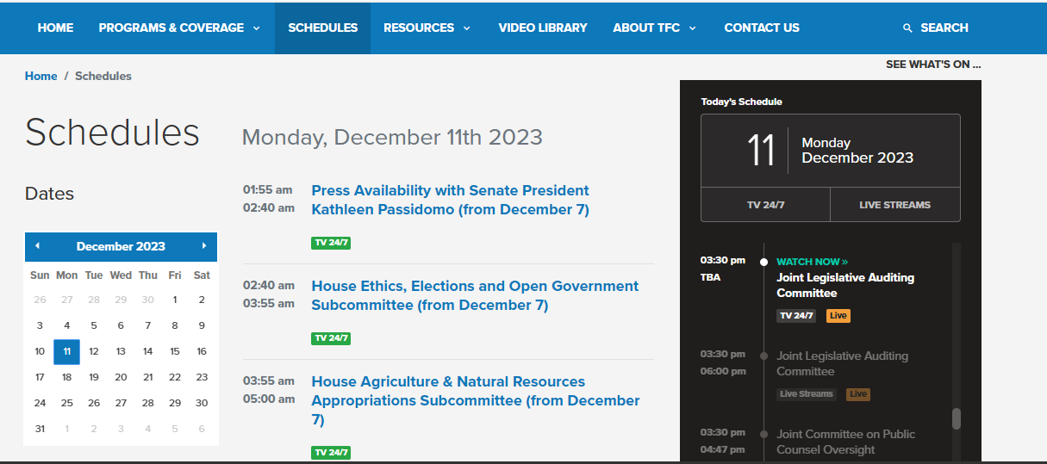
Check Out the Video Library for archived sessions. You can watch LIVE as well!

- The Florida House of Representatives – https://www.myfloridahouse.gov/
Sign up to receive daily/weekly updates of your bills of interest.

- The Florida Senate – https://www.flsenate.gov/
Sign up to receive daily/weekly updates of your bills of interest.

- The Legislative Claim Bill Manual [Has not been updated for 2025]- https://www.flsenate.gov/PublishedContent/ADMINISTRATIVEPUBLICATIONS/leg-claim-manual.pdf

Important Dates to Remember

ACTIVITY | DATE
Interim Committee Week 1 | October 6 – 10, 2025
Interim Committee Week 2 | October 13 – 17, 2025
Interim Committee Week 3 | November 3 – 7, 2025
Interim Committee Week 4 | November 17 – 21, 2025
Interim Committee Week 5 | December 1 - 5, 2025
Interim Committee Week 6 | December 8 – 15, 2025
Start of 2026 Legislative Session | January 13, 2026
End of Legislative Session | March 13, 2026
Democratic Women’s Clubs Tally Days | To Be Determined

DWCF Legislative Categories

ALL ISSUES ARE WOMEN’S ISSUES – SUBJECT AREAS
Civil, Human, & Immigration Rights | Health & Safety
Criminal Justice & Legal | State Preemption
Education | Voting & Elections
Economy & Infrastructure | Women, Children, Family, & Elder Affairs
Environment | Miscellaneous (Housing, Insurance, etc.)
Gun Safety

Toolkit Resources

- Zoom Recordings

- Democratic Women’s Club of Florida Website
Sign Up Here: https://www.dwcf.org/

- Florida Watch – A communications and research organization with a digital-first lens. They serve as the progressive community’s in-state hub for message development, digital communications, and research.
Join the Communications and Strategies Weekly Updates –
Sign Up for Updates: https://floridawatch.org/get-involved/

- Technologies
  - Perplexity – https://www.perplexity.ai/ - A free AI-powered answer engine that provides accurate, trusted, and real-time answers to any questions, including legislative bills.

  - Bill Track 50 – https://www.billtrack50.com/ - A simple search tool for state and federal legislation and regulations, and assemble your results into a spreadsheet-style grid for you to view and enjoy.

  - Digital Democracy Project – https://digitaldemocracyproject.org/ - Vote on the same bills as your representatives on this free mobile voting app. Produces a voting scorecard that compares what voters want to what legislators deliver.

  - Voatz – https://voatz.com/ - Secure, accessible mobile voting at your fingertips, anywhere, anytime.

  - Fast Democracy – https://fastdemocracy.com – For politically interested individuals who want to follow legislation & contact legislators.

